ENERGYMANAGEMENTCENTRE–KERALA
Sreekrishna Nagar, Sreekariyam P. O
Thiruvananthapuram -695017

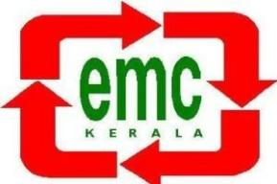

CITIZENS’CHARTER

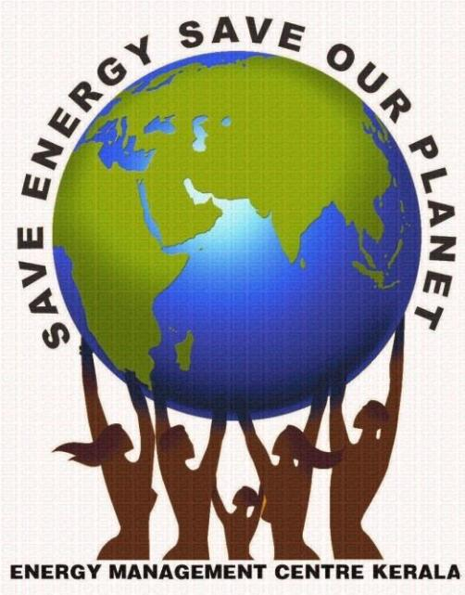

ENERGYMANAGEMENTCENTRE–KERALA

Sreekrishna Nagar, Sreekariyam P. O Thiruvananthapuram -695017

CITIZENS’ CHARTER

Energy Management Centre -Kerala (EMC) is an autonomous body under Department of Power, Government of Kerala, registered under theTravancore- Cochin Literary, Scientific and Charitable Societies Act of 1955 with Reg.No: 139/96. The Centre came into existence on 07 - 02- 1996. The office of the organization is situated at Sreekariyam, Thiruvananthapuram. (About 100 M from Chavadimukku towards College of Engineering, Kulathoor). EMC is the State Designated Agency to enforce, regulate, co-ordinate and to implement the provision of the Energy Conservation Act 2001.

Our Vision:
Achieving maximum Energy Efficiency in all sectors of economy by participating all sections of people.

Our Mission:
To make energy conservation, a cultural entity in the process of sustainable developmentthrough efficient energy management.

Objective:
To facilitate efficient management of all forms of energy, to promote energy efficiency and energy conservation and to develop new sources of energy as well as novel energy technologies with a view to increasing production, improving the quality of life and facilitating the use of energy on a sustainable basis. Energy Management Centre promotes and provides facilities and information mainly through 3 divisions of this Centre viz.ECBC,S&L,SHP Division, NMEEE & DSM Division and Information Technology Division.

ECBC,S&L,SHP Division

ECBC, S&L, SHP division of the Energy Management Centre, Kerala is dealing with areas relating to the Energy Conservation Building Code (ECBC), small hydro power, and standards and labeling. The Energy Conservation Building Code (ECBC) was launched in May 2007 by the Bureau of Energy Efficiency (BEE), Ministry of Power to reduce the adverse impact of buildings on the environment. ECBC defines norms of energy performance for various building components and takes into consideration, the climatic region. The application of these norms lowers the building’s energy requirement without affecting the function, comfort, health or productivity of the occupants. The division has taken initiatives for speedier development of Small Hydro Power (SHP) in Kerala, with people’s participation. Altogether, the projects division dealt with environment-friendly systems of development of power especially, Small Hydro Power with a sustainable development initiative. Small and mini hydel potential can provide a solution for the energy problems in remote and hilly areas where the extension of the grid system is comparatively uneconomical. One of the main activities of the Energy Management Centre is therefore to develop, introduce and promote electricity generation techniques and programme through SHP. EMC also enforces Standards & Labeling, which is a BEE scheme and supports its main objective to provide the consumer with an informed choice about energy saving and thereby the cost-saving potential of the relevant marketed product. The scheme targets the display of energy performance labels on high energy end-use equipment & appliances and lays down minimum energy performance standards..
The various activities of this division are as follows :
- Total Consultancy and Project Report Preparation of Small/ Mini/ Micro project for local bodies/ Pvt. Developers.
- Renovation and modernization of small/ mini/ micro projects developed by panchayaths.
- Provide consultancy for the development of micro hydel turbines suited to off-grid areas.
- Provide technical assistance for ECBC & ENS implementation and enforcement in the State.
- Provide technical assistance to commercial & residential buildings to ensure ECBC & ENS compliant design respectively.
- Organize ECBC & Eco Niwas Samhita (ENS) awareness workshops and training programme as per the BEE scheme.
- Star rating of commercial and residential buildings as per BEE scheme.
- Conducting retailers meet on standards and labeling programme in 4 zones of Kerala. The zones are Thiruvananthapuram, Kochi, Kozhikode, and Kannur. In last year, the programme was conducted by Vivekananda Global University for EMC.
- Issuing a letter to all electronic dealers in Kerala about mandatory star labeling and voluntary star labeling.
- Conducting public awareness programme on mandatory and voluntary star labeling for energy-saving and thereby cost-saving potential of the product.
- Prohibit manufacture, sale, import, or deal in appliances and equipment not meeting S&L requirements/standards.
- Inspect and enforce compliance.

NMEEE & DSM Division

This division helps to implement the objectives of the Centre, to facilitate efficient management of all forms of energy, to promote energy efficiency and energy conservation and to develop new sources of energy as well as novel energy technologies with a view to increasing production, improving the quality of life and facilitating the use of energy on a sustainable basis.

In particular the objects are :

- Total Consultancy and Project Report Preparation of Small/ Mini/ Micro project for local bodies/ Pvt. Developers.
- To develop innovative methodologies and techniques and devise programmes for efficient energy management.
- To identify barriers to improving energy efficiency and propose appropriate remedial approaches including policy measures and financial incentives.
- To carry out, support and promote research studies on energy management.
- To advise various sectors of the economy like industry, transport and agriculture etc., the agencies connected with energy production, handling and utilization and the Government on issues related to all forms of energy and its efficient management.
- To monitor and promote energy conservation activities in the State of Kerala.
- To increase the skill and capability of energy professionals.
- To facilitate the exchange of energy experts between the state of Kerala and other regions within India and abroad.
- To perform such other functions as desired by the Government and undertake such other activities as are relevant to fulfil the objects of the Centre.

Other services include :

- Facilitating Energy Auditing in Government and private buildings in Kerala for assessing energy conservation potential and also to make these buildings as model energy-efficient buildings.
- EMC isregularly conductingtraining, awareness,demonstration programmes to the general public, skilled and unskilled employees of industries, students, and housewives, etc. to make aware of the need for energy conservation.
- Vide. G.O (Rt) No. 2/2011/P.D dated 01-01-2011, Govt of Kerala had made energy audit mandatory for all HT/EHT consumers in the State of Kerala, except Designated Consumers. For conducting a mandatory energy audit EMC had empanelled 49 energy auditors from inside and outside Kerala. The name of the empanelled energy auditors along with their profile is published on the EMC website (www.keralaenergy.gov.in).
- EMC is supporting the Government/ Public buildings for carrying out energy audits at their facility to identify the energy-saving opportunities in their facilities.
- EMC in association with various other Govt and Private departments has done R & D activities in Energy conservation to find new, innovative, and cheap ways of energy conservation. Almanac-fed LED Street light system, Thapabharani, are some of the items.
- As part of enhancing energy efficiency in Government/ Public buildings, EMC is implementing energy efficiency activities of retrofitting inefficient appliances with energy-efficient appliances.
- With the aim of making an entire Village an energy-efficient village, EMC is in the process of implementing the Model Energy Efficient Village programme. Under this programme, the energy audit of all Government buildings, implementing the energy-saving recommendations identified through the energy audit, supply of energy-efficient appliances to domestic consumers in subsidized rates, and energy conservation awareness programmes to all sectors of the economy.
- To ensure energy efficiency at the Assembly Constituency level, EMC is implementing the “Urjaya” programme. Under this programme, the energy audit of Government buildings including schools will be carried out, and retrofitting of inefficient energy-efficient appliances will be carried subject to the availability of funds available.
- EMC had already published an Energy Audit Manual, way back in 2011 itself, in which details regarding energy audit, what all areas to be covered in an energy audit, how to prepare an energy audit, and instruments required for an energy audit are explained. EMC along with National Productivity Council, Chennai and make it more effective and useful has revised the energy audit manual in 2017. The new energy audit manual is a price edition and is made available to the public.
- With the aim to minimize energy conservation in the agriculture sector, EMC is organizing awareness programmes for farmers in associating with Krishi Vinjan Kendras and is implementing an energy-efficient agriculture pump programme that aims to retrofit inefficient agriculture pumps with energy-efficient agriculture pumps.
- Facilitating MSME units for carrying out energy audits and implementation of energy efficiency activities at their facilities.
- To uplift the women-owned MSME units in the State, EMC has launched a programme exclusively for women entrepreneurs which facilitates them to increase the energy efficiency of their units. EMC will provide technical and financial support for carrying out energy audits, implementation of energy efficiency enhancement projects, and awareness programmes to all employees of the units.
- For creating energy professionals and energy ambassadors, EMC in association with NGOs is conducting certification courses.
- EMC is supporting to conduct of Energy Audit/ Energy Efficiency studies in different organizations with a view to reduce energy consumption and to improve energy efficiency, which ultimately leads to enhancement of profitability.

Information Technology Systems Division

The IT Systems Division of the Centre is running the Centre’s IT facility and websites and provides necessary computing facilities and IT infrastructure to the SHP Cell, Govt. of Kerala, and UNIDO Regional Centre for SHP and its project locations in South Asia. The Division works with other divisions in EMC and organizations in Kerala to provide IT services and training to staff members and project trainees/ students.

LABORATORY FACILITIES

EMC has a well-equipped laboratory. Various instruments are currently available and used for R& D and Consultancy works. Energy Meter Calibration Laboratory (EMCL) of Energy Management Centre- Kerala has been accredited in accordance with the standard ISO/IEC 17025:2017. The National Accreditation Board for Testing and Calibration Laboratories (NABL) has issued the certificate for accreditation (certification number: CC 3211). Energy Meter Calibration Lab consists of a Three Phase Fully Automatic Test System with 0.1 Accuracy class and reference meter of 0.2 Accuracy. The lab personnel are well trained in ISO 17025:2017 and well versed in relevant BIS standards for energy meters. The environmental condition of the lab stipulated by NABL is maintained and in the process of NABL accreditation. LAB is capable of calibrating/ testing all types of HT and LT energy meters up to an accuracy class of 0.2/0.2s which includes the following types.

- Bidirectional Meter/ Net Meter- Three phase and Single phase
- Direct current Three Phase and Single Phase meter
- Three Phase CT Type meter
- Trivector meter

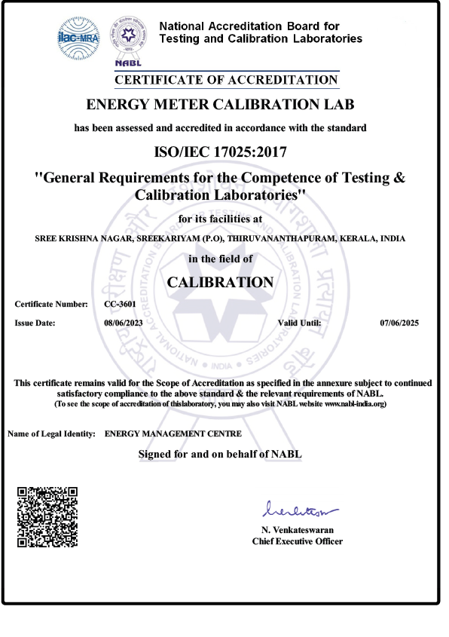

The fee structure for meter calibration at this lab is as follows. All rates are including GST.

Energy meter
Type of Meter | Fee for calibration (Incl of GST)
Single phase two wire AC energy meter | 335
Single phase two wire NET AC energy meter | 665
Three phase Four wire AC energy meter | 555
Three phase Four wire NET AC energy meter | 1105
Three phase Trivector Meter Active import and export (Unidirectional) | 1105
Three phase Trivector Meter Active/Reactive import/ export (Bidirectional) | 2205

Noticing the idling period of Power Quality analysers/Power loggers used for Energy Auditing, Evaluation of electrical parameters of electrical equipment, energy and load studies, etc as available in EMC, it is herewith decided that that meter can be leased out to agencies doing energy audits and allied activities upon their request against a lease rent/fee inclusive of GST with rates as per the following schedule and period.
Rates including GST as per allowable period
Type of Meter | Up to one week | more than one week but up to one fortnight | Monthly
Power Quality and Energy Analyser (Fluke 435) | Rs.5000/- | Rs. 9000/- | Rs. 15,000/-
Power Logger (Hioki) | Rs 1000/- | Rs 1500/- | Rs 2,200/

The current rates of rent for other equipment areas follows:

Sl. No | Name of Equipment | Rent perday
1 | Infra Thermometer | Rs.1000/-
2 | Lux Meter (with Technician) | Rs.800/-
3 | Lux Meter (without Technician | Rs.500/-
4 | Temp Indicator (without Technician | Rs.350/-
5 | Temp Indicator (with Technician) | Rs.500/-

These rates may change as per the decision of the Executive Committee. On submission of application/ request with the prescribed fee, the services will be rendered on the same day itself.
LED Testing Lab: Energy Management Centre - Kerala has setup a Lighting and Luminaries Test facility. The the testing rates as follows
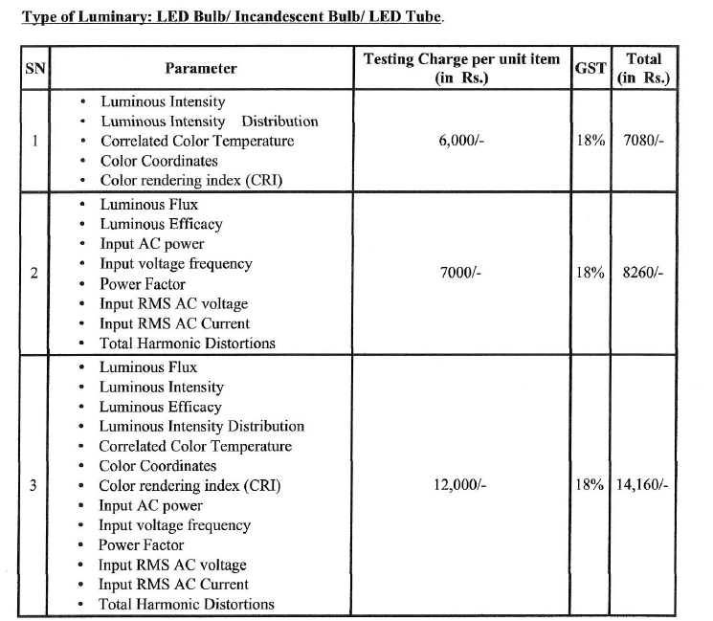

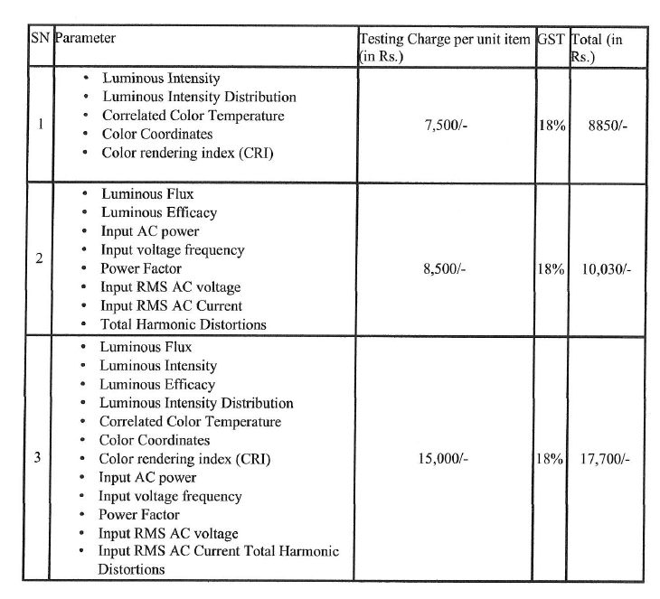

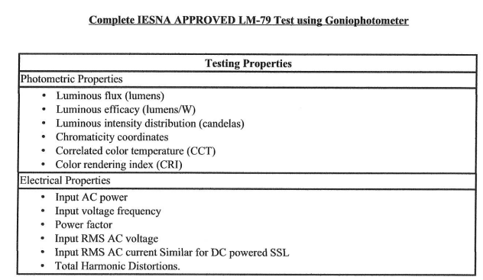
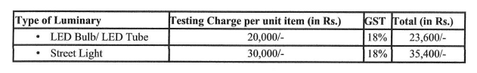

LIBRARY

EMC has a library of 3886 books on various subjects and 42 journals and newsletters, particularly in Energy and Environment Management. EMC library is structurally conceptualized as a multi-disciplinary one, capable of providing an adequate information base for energy-related subjects in renewable, energy conservation, Environment, Energy Management, and non-renewable energy sources. EMC Library is open for reference to Engineers, Scientists, and Faculty/Students of Research Institutions. In order to become a member of the EMC library, interested parties have to submit application forms along with membership fees, which may be paid in cash or DD in favor of the Director, Energy Management Centre payable at Thiruvananthapuram.

Fee Structure (For Reference)

- Individuals : Rs. 250 per year
- Institutions: Rs. 1000 per year (2Cards)

Those who want to take out the books from the Centre should deposit an amount of Rs. 5000 (which will be reimbursed on termination of membership).On submission of application/ request with the prescribed fee, the services will be rendered on the same day itself.

RESEARCH CUM DEMONSTRATION PROJECT

The Centre has been conducting Research and Development Activities related to efficiency improvement in Small and Medium Enterprises (SMEs) and energy-efficient monitoring systems for industries and also for the development of energy-efficient cooking aids etc. EMC also conducts Energy Conservation Programmes, Demonstration programmes, Education, Training &Awareness programmes in Industries, Govt. Departments, Educational Institutions, Local Self Governments, House wives, etc.

KERALA STATE ENERGY CONSERVATION AWARDS

Every Year, awards are given to recognize selected enterprises, organizations, individuals, and students who have made systematic and serious attempts for efficient utilization of energy, conservation of energy, research, and promotion of energy efficiency.

Further details are available on our web site: www.keralaenergy.gov.in

Web Portal

EMC has developed a web portal to attend the diversifying activities on the implementation of the Energy Conservation Act 2001, like from; Designated consumers, Energy auditors, Energy managers, Energy clinic volunteers, energy club members. The web portal www.keralaenergy.gov.in enables to unify information from categories; e-filing of energy data by designated consumers, report submission of Energy Clinic Volunteers, activities of energy auditors and managers. This single point access is making use of all these categories for effective working.

Energy Information Bureau

EMC has developed a Toll -free Energy Information Centre. Through this centre consumers can get free information about new technologies of energy efficiency, energy conservation, Star labeling, and other information about EMC. The toll-free number is 1800 425 5256. In addition to the above activities, the following Centers and Cell are also functioning in EMC and their services are detailed below:

Small Hydro Promotion Cell

Small Hydro Promotion Cell under the Department of Power is also functioning in Energy Management Centre for promoting Small Hydro Power projects in the State. This Cell is functioning as a technical secretariat under Secretary (Power) for the administration of implementation agreements executed with the Government by various power producers. The government has allotted 12 small hydro Schemes totaling 43.75 MW to various Captive/ Independent Power Producers and revived two schemes totaling 22MW. Through this initiative, 10MW capacity SHP projects were commissioned and the remaining projects were under various implementation. The Small Hydro Power Promotion Cell set up in EMC by the Government of Kerala gives vital support to develop Small Hydro Power Projects in the state through Local Bodies and private participation.

UNIDO Regional Centre at EMC for Development of Small Hydro Power in South Asian Region

The UNIDO Regional Centre for SHP was established in 2003 as a project of UNIDO, Govt. of India, and Kerala Government and is functioning in EMC. The Centre has a liaison with UNIDO and International Centre on Small Hydro Power to implement a mini hydel project at Pampumkayam (110kW) in Mankulam Grama Panchayat hand has commissioned the project in October 2004. As part of the activity, the Regional centre prepared Detailed Project reports for 8 SHP schemes. Three new MHP schemes were identified in and around Mankulam. 3 International workshops were organized under the aegis of UNIDO.

ENERGY EFFICIENT APPLIANCES THROUGH URJAMITHRA CENTRES IN KERALA

Urjamithra–AkshayaUrja Service Centres are set up by ANERT, an autonomous organization under the Government of Kerala in 140 Legislative Assembly (LA) constituencies in the State. Urjamithras are intended to provide services to the public and timely maintenance of the renewable energy devices installed at public places and households. In order to encourage Energy Efficient appliances/equipment usage, EMC is implementing projects for the replacement of existing equipment with energy-efficient equipment in Government buildings such as schools, colleges, offices, etc. EMC has decided to utilize the de-centralized collaborative network of Urjamithras for the supply of energy-efficient appliances/equipment in Kerala.

EMC started the empanelment of manufacturers/ distributors/ traders of BEE star labeled appliances/equipment and other certified energy-efficient products, and collect the lowest price for the delivery of the same at Urjamithra centers in Kerala State. Through this empanelment process, the public would be getting a choice of selection from a wide range of energy-efficient products at affordable prices at Urjamithra centers. The products listed by the empanelled vendors shall be exhibited in the e-market portal named Save Energy Mart (savenm.in) managed by EMC-Kerala where the Urjamithras can place the orders from the empanelled vendors and distribute the same to the public through Urjamithra centers. The public will also have the facility to locate the Urjamithra centres and place interest in products available in each Urjamithra centre through this portal.

“GO ELECTRIC ” CAMPAGIN

To spread awareness on the benefits of e-Mobility, EV Charging Infrastructure, and clean & safe electric cooking in India, the central government has launched the “GO ELECTRIC” Campaign on 19th February 2021. As EMC is the nodal agency of the Bureau of Energy Efficiency (BEE) to carry out the awareness campaign of the “Go Electric” campaign, EMC is carrying mass awareness on the benefits of EVs and electric at the state level in collaboration with the Industry stakeholders, relevant line ministries & departments. The State Level launch of the campaign was started on 5th June 2021 and more than 19 webinars were carried out and the awareness programmes are still continuing. The state-level inauguration of this campaign was held on June 5, 2021. As part of this campaign, a webinar is organized every week of the year. On June 10, 2021, as part of the Go Electric Campaign, a virtual exhibition was organized involving the leading manufacturers of major electric vehicles and electric cooking utensils. The aforementioned webinars were also broadcast on EMC's official Facebook page.

As part of the “Go Electric” campaign EMC in association with M/s. Convergence Energy Services Limited (CESL), a subsidiary of Energy Efficiency Services Limited, Ministry of power, Government has launched a scheme for “Sale of electric two wheelers to Public in special rate”. As per this scheme, electric 2 wheelers are sold to the public at reduced rates through an online portal (www.myev.org.in). The electric 2 wheelers can also be booked through a mobile app titled, MyEV, available both for Android and iOS. For operating this scheme, CESL has empanelled selected manufacturers of the electric 2 wheelers after inviting nationwide tender. The electric 2 wheelers are sold to the public through the existing dealers of the manufacturers and the service will also be provided through the dealers of the respective manufacturers. The exhibition of electric vehicles available under the above scheme was held from 1st to 4th September 2021 at the Vellayambalam Institution of Engineers Ground. Under this scheme, the general public in Kerala will be able to purchase electric 2 wheelers at below-market prices. To implement this project, CESL Electric has invited tenders from manufacturers of 2 wheelers nationwide and has empanelled 6 vehicle manufacturers. Electric 2 wheelers from the above-mentioned automakers are available for booking to the public through the website www.MyEV.org.in and also through the MyEV mobile app (available on Google Play Store and Apple App Store). This is the first time in India that E-vehicles have been made available for purchase through a portal. These vehicles will get a subsidy of Rs 20,000 to Rs 43,000.
URJA KIRAN
This programme, in general, focuses on enhancing environmental awareness and fostering critical thinking and problem-solving approaches among participants, by helping them to become actively involved in the exploration of their immediate environment, through understanding certain concepts and undertaking some selected activities related to energy conservation and energy efficiency. Centre for Environment and Development (CED) is selected as the Resource Agency (RA) for organizing and monitoring the programme through the empanelled agencies all over the state.The objective of URJA KIRAN is to create awareness among the general public and equip them for efficient management of all forms of energy, to promote energy efficiency and energy conservation, and to develop new sources of energy as well as novel energy technologies with a view to increasing the production and facilitating the use of energy on a sustainable basis. It aims at seeking the Participating Agencies (PAs) to convene, catalyze and facilitate works in the energy conservation-related activities in a participatory mode across 140 legislative assembly constituencies of the State. Therefore, institutions that have been involved in community participation, environment, and energy conservation work are invited to apply for the task.

SMART ENERGY PROGRAM

The Smart Energy Program (SEP) of EMC aims at awareness creation among students on energy conservation and environment-friendly energy technologies as this would help in inculcating a habit in the younger generation on the judicious use of the scarce and depleting energy resources. Smart Energy Program is one of the flagship projects of EMC, which was formed to spark off an initiative for curbing energy wastage through active measures and also popularizing the importance of energy conservation energy efficiency measures among students. Its activities include improving the energy efficiency of schools by replacing inefficient equipment and National Energy Conservation Day celebrations. SEP also aims to improve energy conservation awareness among students through quiz competitions and webinars.

Service Availability

EMC is committed to providing the services during office hours on all working days. The facilities are provided mainly through three Divisions (viz) NMEEE & DSM Division, ECBC, S&L, SHP Division, and Information Technology Division.

Procedure/ Time limit

Procedure to avail the services and information and cost of services are as under :
Sl No. | Services Offered | Division to be  contacted | Costof  Service | Time Limit
1 | Support toconduct Energy Audit of Govt/ Pvt. buildings and also industries inPublic/ Pvt Sector–To assess energy conservationpotential through the EMC empanelledEnergy  Auditors. | NMEEE & DSM Division | Based on Man days and technical equipment by the Energy Auditfirm. | The details of the Energy Audit firms are available in the web-site. If needed details will be given within five days
2 | Energy Conservation clubs in schools and Energy Environment Clubs in Colleges/polytechnic. | -Do- | Free of cost | Within 10 days after the receipt of request from school/college  Authorities.
3 | Training, Awareness,  Demonstration  programmes/workshopsfor various groups(Resident Association, Skilled/ unskilled workers of industries,students,  house wives etc. | NMEEE & DSM Division | Normally free of cost / EMC will also organize paid programmes | Within15 days after receipt of request.
4. | Awareness on Star Labelling | -Do- | Normally free of cost / EMC will also organize paid  programmes | 1 day.
5 | Consultancy/ Project  Report/ Renovation and Modernization of Small Hydro projects. | ECBC,S&L,SHP Division | Based on size and scope of the project. | The initial work will commence within  15 days of receipt  of request.
6 | Consultancy for development of  Micro Hydro Turbine | -Do- | -Do- | -Do-

Grievance Redressal
In case you are not satisfied with the services provided by the Centre, please send your complaints to the Director by name by post or e-mail or can contact through telephone. You can also meet the Director in person on all working days

Time Limit
Your complaints/ suggestion will be acknowledged immediately. Appropriate action will be initiated for redressal within 15 days.

Contact persons :

Director : Dr. R. Harikumar
Tel: 0471 -2594921, 2594922, 2594924 , Fax: 0471 -2594923
E- mail: director@keralaenergy.gov.in
Website: www.keralaenergy.gov.in

Registrar: Subhash Babu B. V
Head, ECBC,S&L,SHP Division: Dinesh Kumar A. N
Head, NMEEE & DSM Division: Johnson Daniel
Head, I T Systems Division: Suwilkumar W S
Finance Manager: Sandeep K

